WealthBuilders Financial Group, Inc.
2154 Seven Springs Blvd Trinity, FL 34655
(727) 843- 0151 (800) 249- 6620
www.WealthBuildersFinancialGroup.com

Market Volatility: A Normal Part of the Investment Experience
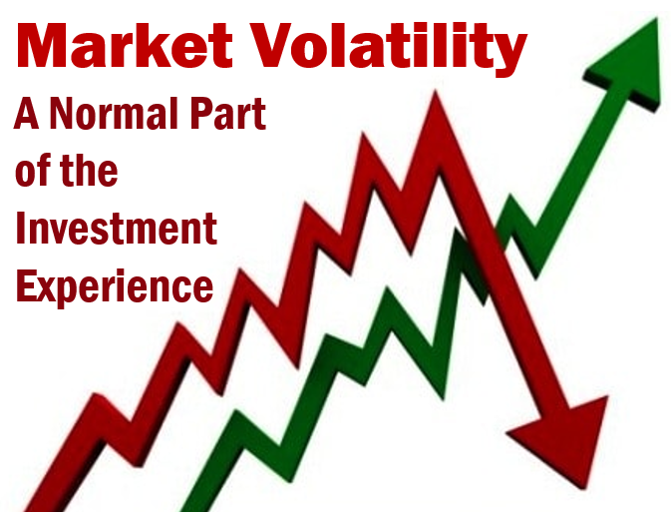
Baseball legend Yogi Berra once said, "It's tough to make predictions, especially about the future." This holds true when it comes to timing the stock market. Investment markets have recently experienced a few years of very strong returns, but market volatility has returned in early 2022 in a big way. Veteran investors understand that market volatility is a part of the investment experience.

Stock market volatility is the frequency and magnitude of price movements, up or down. The bigger and more frequent the price swings, the more volatile the market is said to be. For example, when the stock market rises and falls more than one percent over a sustained period of time, it is called a "volatile" market.

Beyond the market as a whole, individual stocks can be considered volatile as well. You can calculate volatility by looking at how much an asset's price varies from its average price. Standard deviation is the statistical measure commonly used to represent volatility. During volatile times, some stocks are more volatile than others. Shares of an established large blue-chip company may not make very big price swings, while shares of a high flying and newer tech company may do so often.

Stock market volatility can speed up when external events create uncertainty. Currently, the potential conflict overseas, the Federal Reserve’s shift in policy and the resurgence of inflation have all been noted as contributing factors to the recent equity market volatility.
Volatility doesn’t mean that stocks are headed for a down or long lasting bear market. Even when there are market declines along the way, an investor can still experience reasonable returns over a long period of time.

Why is volatility important?

By understanding how volatility works, you can put yourself in a better position to evaluate stock market conditions as a whole. You can analyze the risk involved with any particular security, and construct a stock portfolio that is a great fit for your growth objectives and risk tolerance.

It's important for investors to be aware that volatility and risk are not the same thing. For stock traders who look to buy low and sell high every trading day, volatility and risk are deeply intertwined. Volatility also matters for those who may need to sell their equities in a short time-frame, such as those who are older and closer to retirement.

For long-term investors who tend to hold equities for many years, the day-to-day movements of those equities should not affect their long-term plan`. Volatility is part of the noise that could come while you are allowing your investments to compound long into the future.

Long-term investing still involves risks, but those risks, are most of the time, related to being wrong about a company's growth prospects or paying too high a price for that growth -- not volatility.
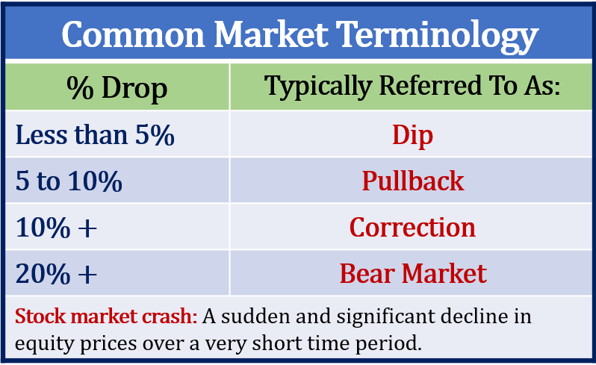
A quick review of some market terms.

Oftentimes, we hear the wrong words used in the wrong context. For educational purposes, we feel it is important to clarify some stock market words and their definitions.
“Dip” - a short-lived downturn from a sustained longer-term uptrend.
Example: Equity markets increased by 5% and maintained that level and then dipped back down to 3% all within a few days or weeks.
“Correction” - a 10% drop in the market from recent highs. Historically corrections occur an average of about every eight to 12 months and last about 54 days. (thebalance.com 3/9/20)
Example: On December 17, 2018, both the DJIA and the S&P 500 dropped over 10% and declines continued into early January.
“Bear Market” - a long, sustained decline in the stock market. If the market declines 20% from its recent high, this is considered the start of a bark market.
Example: On Wednesday, March 11, 2020, The DJIA dropped 5.9%, for a total decline of 20.2% from a record high on February 12, 2020.
“Crash” - a sudden and dramatic drop in stock prices, often on a single day or week. Crashes are rare, but typically happen after a long-term uptrend in the market.
Example: In 1929 the market crashed when it lost 48% in less than two months, ushering in the Great Depression.

Four things an investor should know
about a volatile market.

One of the main reasons investors can get high returns over the long run is because occasionally they experienced and lived through downturns in the short run. Please note that:

- Volatile times can create market drops that can be UNCOMFORTABLE, but they are not UNFAMILIAR. Downturns are a part of the investment experience.

- Equity markets always offer Exit and Entry points. Over long periods of time, down markets are many times the best entry point for for new or additional monies.

- You make money in equities, when you BUY LOW and SELL HIGH. A bad emotional decision can lose an investor more money than any market correction.

- Call us if you are concerned. We are here for you!

Position yourself to best
navigate market volatility.

Market declines happen and therefore, no matter what equity markets are doing, your plan should align itself with these three items.
- Your investing goals,
- Your financial timeline, and
- Your risk tolerance.

Your Investing Goals
Every investor has unique goals they would like to attain. Knowing what your goals are is the first step to creating a path to achieve them. Your goals will determine your time horizon and risk tolerance.

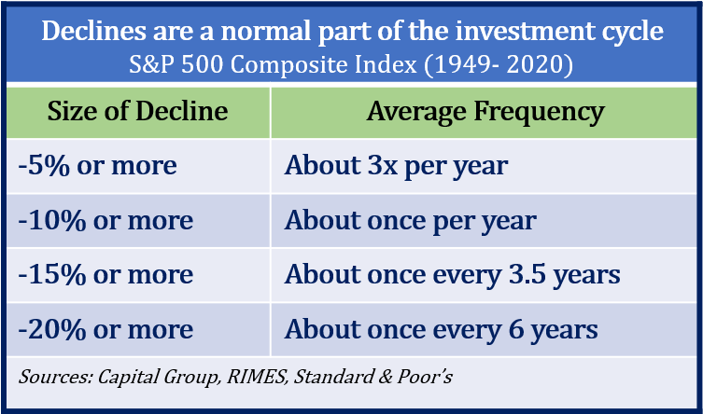
Your Financial Timeline
Focus on your personal timeline instead of trying to time the market. During downturns, it may be tempting to pull out of the market, but you may miss out on a healthy recovery. Try to plan for your equity investments to maintain a long-term horizon and ignore the short-term fluctuations.
Remember, short-term movements of the market are unpredictable and do not abide by any average. For many long-term investors there is no reason to even subject themselves to daily market headlines. If you have a long-term investment horizon for your equity holdings of at least five years, chances are the current volatility will pass - possibly in a couple of weeks, months or at the most, a few years.
According to a JP Morgan analysis, even missing a few days of a market recovery can be costly. This analysis looked at the S&P 500 over a 20-year period (January 2000 to December 2019). Investors who stayed fully invested would have earned more than 6% annually. However, those investors who missed just ten of the days with the highest daily returns would have earned only 3% annually. During those 20 years, six out of the ten best days occurred within two weeks of one of the worst 10 days.
Your Risk Tolerance
Risk tolerance is the level of uncertainty you are willing to accept in order to reap potentially greater rewards. Knowing what your risk tolerance is, or risk awareness, should be part of your financial plan. As your financial professional, one of our primary goals is to help you create a plan that considers your risk tolerance. If you are not sure what your risk tolerance is, please call us and we and help you assess and determine this for you.

What should an investor do
in a volatile market?

First, make sure you know what not to do - and that is panic. In times of market volatility, investors tend to become unnerved and anxious. This is not the best mindset to make rational decisions.
When equity markets experience unsettling fluctuations, we suggest you ask yourself three questions:

- Have my financial timelines changed?
- Have my financial goals changed?
- Has my risk tolerance changed?
If you can answer “YES” to any of these questions, we highly suggest that you discuss these changes with us. As an investor, you need a plan that includes risk awareness. One of our primary responsibilities as your financial advisor is to help you create a plan with risk awareness. We know that an integral part of this is to consistently keep in touch with you and monitor your situation.
If you have concerns, some questions to ask us include:
- Can we review my financial plan?
- Can we revisit my risk tolerance?
- Are my investments diversified?
- Has the volatility presented any good opportunities?
Regardless of whether or not equities are rising or falling, investors should always put their main focus on their own personal objectives. This includes:
- Making sure you are comfortable with your time horizons.
- Re-assessing your risk tolerance.
- Re-confirming your investments are compatible with both your time horizon and risk tolerance.
- Maintaining liquidity for all short-term and near-term needs.
Our primary responsibility is to
focus on your personal financial goals.
We still maintain our “proceed with caution” approach. If your risk tolerance or goals have changed, or if you have any questions or concerns, please call us.
Market volatility should cause concern, but panic is not a plan. Market downturns do happen and so do recoveries. It is always healthy to confirm that you fully understand your time horizons, goals, and risk tolerances. Looking at your entire picture can be a helpful exercise in determining your strategy.
It is always helpful to make sure you are comfortable with your investments. Equity markets will always have the potential to move up and down. Even if your time horizons are long you could see some short-term downward movements in your portfolios. Make sure your investing plan is centered on your personal goals and timelines. Peaks and valleys have always been a part of financial markets and it is highly likely that trend will continue.
Discuss any concerns with us!

We are always available to revisit your financial holdings to make sure they are still in line with your timeline goals and risk tolerance.

As a reminder, please keep us apprised of any changes, such as health issues or changes in your retirement goals. The more knowledge we have about your unique financial situation, the better equipped we will be to best advise you.

To discuss your situation with us please address it at our next meeting or call our office.
Please share this report with others!
Our goal is to offer services to other clients just like you! If you would like to share this article with a friend or colleague, please call SARAH at (727) 843-0151 and we would be happy to assist you!

Securities and advisory services offered through Independent Financial Group, LLC (IFG), a Registered Investment Adviser. Member FINRA/SIPC.
Wealthbuilders Financial Group and IFG are unaffiliated entities.
James M. Noto, CFP is a Registered Principal offering securities and advisory services through Independent Financial Group, LLC, a registered broker-dealer & registered investment adviser. Member FINRA/SIPC. WealthBuilders Financial Group Inc. and IFG are unaffiliated entities. This article is for informational purposes only. This information is not intended to be a substitute for specific individualized tax, legal or investment planning advice as individual situations will vary. For specific advice about your situation, please consult with a lawyer or financial professional.
This article is for informational purposes only. This information is not intended to be a substitute for specific individualized tax, legal or investment planning advice as individual situations will vary. For specific advice about your situation, please consult with a lawyer, tax or financial professional. The information contained in this report does not purport to be a complete description of the securities, markets, or developments referred to in this material. The information has been obtained from sources considered to be reliable but we do not guarantee that the foregoing material is accurate or complete. Any information is not a complete summary or statement of all available data necessary for making an investment decision and does not constitute a recommendation. Investing involves risk and you may incur a profit or loss regardless of strategy selected, including diversification and asset allocation.
Sources: JP Morgan.com; thebalance.com; Capital Group; RIMES; Standard & Poor’s; Contents provided by the Academy of Preferred Financial Advisors, Inc.

